Chapter 4 Cell addressing schemes in Excel

4.0 Introduction
In this chapter we briefly cover the basics of Excel and explain how to do elementary computations. For experienced readers, most part of this chapter will be familiar. We are covering only those aspects of Excel that are needed to be able to follow the later chapters in this book. For those who have no experience with Excel, spending time with one of the many guides to Excel that are available is suggested. Note that Excel comes in many versions. This book is based on Excel 2007/2010 and for some of the material covered here, earlier and later versions of Excel may do things differently.

When you open Excel for the first time you are presented with Excel's workspace. Fig 4.1 shows a screenshot. Don't let the complexity of the Excel workspace faze you. We will not use most of the things in the Excel workspace and the things we may need shall be explained as we go along. The first thing to notice is a grid with a large number of cells. The cell is the basic unit for input and output of calculations. Into the cells we enter numbers, formulas and view the result of our computations. Each cell has a reference that identifies it.

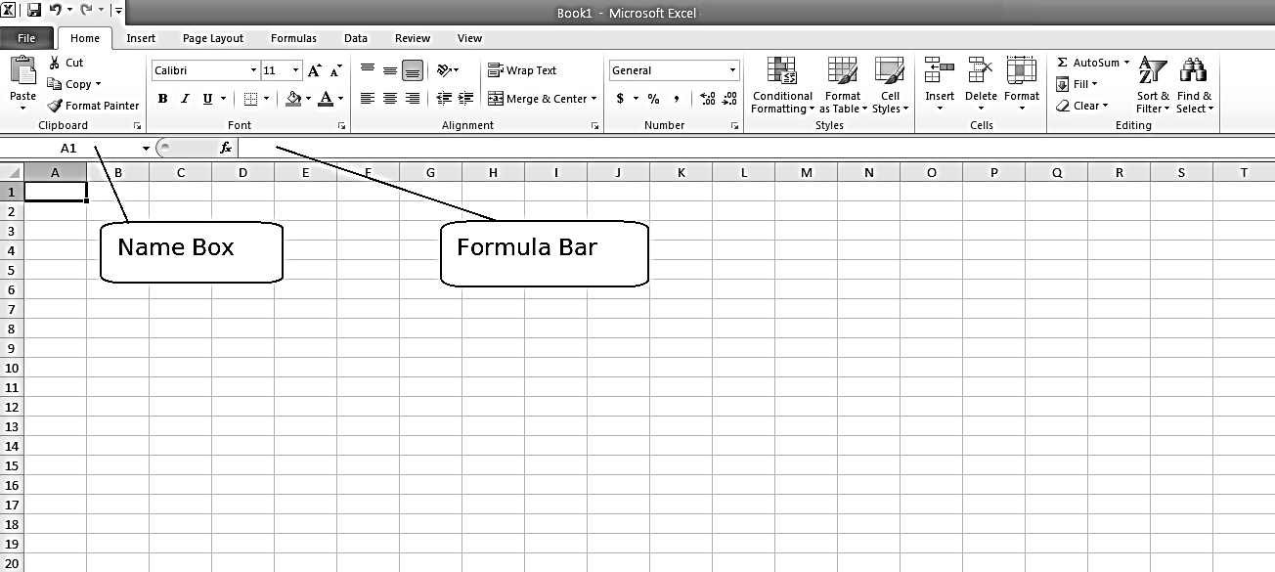
Fig 4 . 1 Name box and Formula bar in Excel sheet

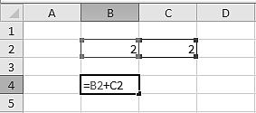
Fig 4 .2 Adding two numbers in Excel

The cell in the upper left corner is referenced as A1. In A1, A refers to column heading (or column address) of the cell A1 and 1 refers to the row heading(Row address). This is some thing like represeting a point in cartesian coordinate system with the pair (x,y) where x is horizontal coordinate and y is vertical coordinate. There are 16384 columns and 1048576 rows in Excel 2010 and so there is plenty of space to work around. The column numbering is somewhat unorthodox. The first 26 columns are referred by A, B… Z. The next 26 columns are referred by AA, AB… AZ. The next 26 columns are referred by BA, BB… BZ and so on. In Fig 2.2 we have entered 2 into the cells B2 and C2. This is done simply by selecting a cell with the mouse and typing 2. To select a cell, point the mouse at the cell and click with the left mouse button. Next, select cell B4 and type =B2+C2. This formula takes the arguments in B2 and C2 and adds them. The result, 4, is shown in B4. As long as cell B4 is selected we can see the formula generating the result in the Formula bar. Of course we could have entered =2+2 and found the same result. Which approach to choose depends on the calculations we want. . See Figure 4.2

Formulas can be almost as complex and as long as we want to, but complicated formulas quickly become hard to read. There are two ways of making complex formulas more transparent. One way is to write user defined functions in Excel's macro language Visual Basic for Applications. We illustrate how to do this towards the end of this book. The other way is to perform intermediate calculations in a number of cells. Say, for example, we have the formula
x = (3² – (5/2))^{–2} and we want to find x. . Entering =((3^2)-(5/2))^(-2) will compute x, but this simple formula becomes hard to read in the formula bar. A more transparent way of doing this calculation is to enter =3^2 into the cell A1 and enter =5/2 into the cell B1 and then entering =(A1-B1)^(-2) into a third cell. Entering formulas like this makes the spreadsheet easier to read and easier to change. Since the number of available cells is huge (16384 rows × 1048576 columns equals a total of 17179869184 cells) you are unlikely to run out of space. Excel has built in all the elementary mathematical operations and using them is straightforward. In order to calculate 2 - 2 we can change the above formula to =B2-C2. Finding 2/2 can be done by entering the formula =B2/C2 and on Multiplying 2×2, by entering =B2*C2. To do powers we use the ^ symbol. Thus =2^2 is the same as 2² and Excel reports the result 4. Excel can also work with negative exponents. The Formula =2^(-2) gives the result 0.25. So does the Formula =1/(2^2) confirming the general rule that a^{–n} = 1/a^{n}.

Excel uses parentheses in the same way as you would use parentheses when making calculations with pen and paper. We can use parentheses in Excel to determine the order in which calculations are done whenever this is important. For example, It is not clear what the formula =3^4*5 means. Is it 3 ^{4x5} or is it 3⁴ x5 It turns out that this formula returns 405. If you want to calculate 3^{4x5} you must enter the formula =3^(4*5). Computer calculations follow certain conventions about the order in which different mathematical operators are performed. For those of us that have a hard time remembering these conventions, using parentheses to specify the order reduces the likelihood of errors. As we all inevitably make mistakes, parentheses are helpful when looking for them. You should, however, be aware that there is a quirk in Excel, which sometimes makes itself known when you are working with parentheses. Occasionally, a formula like =-(A1)^2 will yield the same answer as =(A1)^2. It appears that Excel simply disregards the minus sign! What actually happens, is that Excel disregards the parenthesis and treats the formula as =-A1^2.

A large number of mathematical functions are built into Excel and you can enter them directly into a cell. Excel has a tool called the Function Wizard that helps us find the function we want to use. If we want to calculate $\sqrt{144}$ , we can do this by using an in-built function that calculates square roots.

4.1 Different kinds of Cell addressing in Excel

Definition: A cell address in Excel, identifies the location of the cell in the spreadsheet.
A cell address is a combination of column letter and row number of a cell, such as C4 or D8.
Note: When identifying a cell by its address, the column letter is always listed first followed by the row number.
Cell references are used in formulas, functions, charts , and other Excel commands. While references often refer to individual cells such as A1, B38, or Z345, they can also refer to a group or range of cells.
Ranges (or groups of rectangular array of cells) are identified by the cell references of the cells in the upper left and lower right corners of the range. The two cell references used for a range are separated by a colon ( : ) which tells Excel to include all the cells between these start and end points. An example of a range of adjacent cells would be B5:D10. See Figure 4.3

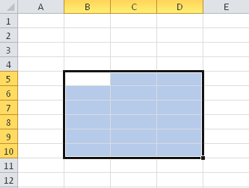
Fig 4.3 Cell ranges represented by B5:D10
4.11 Relative addressing
By default, a spreadsheet cell reference is relative.
To understand what this means, consider the following example.
Let cell A1 has the value 10. In Cell C5 , we write the formula ‘=A1’ and press enter. The cell C5 will now show 10 which is the content of cell A1. Internally , what is getting stored in cell C5 is not the absolute address of the cell A1 but an information which read like this.
“current cell is referring a cell which is two cell left and 4 cell above ”. See Figure 4.4 below
So when we copy this formula in C5 down by one cell, that is to the cell C6, the cell C6 will refer cell A2 – not the cell A1 . Because, when we copy a formula in relative address form , what we are copying is the relationship between the two cells. From C6, the cell corresponding to “two cell right and 4 cell up” is A2.
Similarly if we copy the formula in C5 to D5, the cell D5 will refer cell B1.
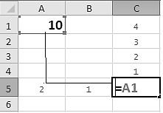
Fig 4.4 Relative addressing – Excel internally store relative address
Note the following
- When formula =A1 is pulled down by one cell, the formula in the new cell become =A2. That is, the ‘number part of the address’ changes by one unit
- When formula =A1 is pulled right by one cell, the formula in the new cell become =B1. That is the ‘Alphabet part of the address’ changes by one unit. Here it changes from A to B
This feature is useful for many applications.
How do we copy formula (or pull down a formula)
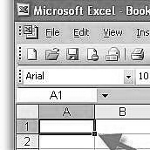
Fig 4.5 Fill Handle
The Fill Handle (see figure 4.5) is the square box in the lower right corner of a selected Excel cell
Filling a formula from one cell to an adjacent cell is one task that can be performed with the Fill Handle
For example suppose we have two columns of numbers as follows. Suppose we want product of two numbers in each row to be displayed in another column. To get the result we write the formula once for the top row and then pull down the fill handle. See the Fig 4.6 and Fig 4.7 below
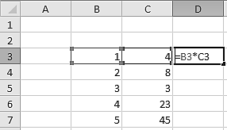
Fig 4.6 Use of relative addressing reduces the job of writng the formula in every cell
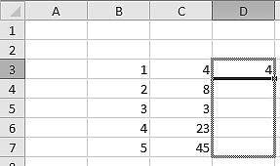
Fig 4.7 Illustrtes relative addressing and copying the formula by using fill handle
If we pull down the formula using fill handle, we get the result like Fig 4.8.
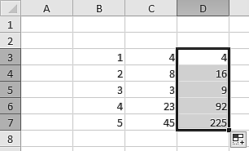
Fig 4.8 Result of the use of relative addressing and copying formula
4.12 Absolute Addressing
We have noticed that, when a formula in relative address form is copied from one cell to another, the formula in the new cell changes. Suppose we want to stop this change, that is when we copy a formula from cell into another, we want the new cell to refer the same cell, we can use absolute address of the cell. This is achieved by appending a “$” sign to both part of the address, e.g. $A$1. Pressing function key ‘F4’ lying on top of the keyboard after typing the required cell address will automatically put this for you. This option does not work in OpenOffice.org Calc where the option is different.
This feature is again useful for many applications.
Consider again the previous example. We want the multiplication corresponding to each row elements and a constant number given in D1 to be added to this (see Figure 4.9 and 4.10).
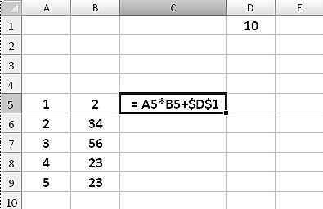
Fig 4.9 Use of relative addressing combined with absolute addressing
If we pull down the output is as follows:
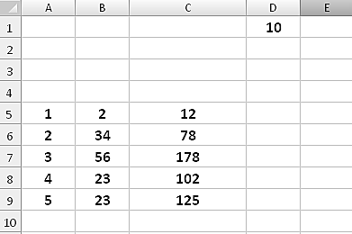
Fig 4.10 Demonstration of use of relative addressing combined with absolute addressing
4.13 Semi -absolute addressing
If we write a formula with $ sign in front of each component of the address like in $A$1, and copy to another cell , it will always refer cell A1 irrespective of the fact that we copied to a cell that is right , left , up or down of the current cell. Now, instead, if we write the formula as =A$1 in any cell, and pull down, it will again refer cell A1. But if we pull one cell right, the formula changes to =B$1 thus referring to cell B1. This is called semi absolute addressing. This feature is again useful for many applications.
We explain its use with an example.
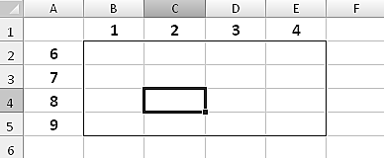
Fig 4.11 Use of semi absolute addressing
Consider Fig 4.11. You can see a rectangular grid with numbers 1, 2, 3, 4 on top and 6,7,8,9 on left of a rectangular grid. Now suppose we want in each cell in the rectangular window a number that is product of numbers given on top and left of margin. For example in cell C4 we want product of 2 and 8. Can we achieve this by writing a single formula in cell B2 and by pulling right and down. Yes! By using semi-absolute addressing method, it is indeed possible.
The required formula in cell B2 is =$A2*B$1. Pull down and horizontally. Result is shown in Figure 4.12
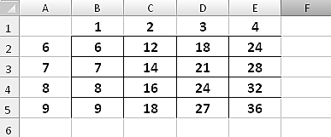
Fig 4.12 Demonstration of the Use of semi absolute addressing
4.14 Examples
Exercise 4.1
Generate multiplication table for any number . The design should be such that , if we change the multiplier given in cell it should generate multiplication table for numbers from 1 to 16 .

The output should be as follows If we change multiplier to 7 , the entire table should change as shown in Figure 4.13
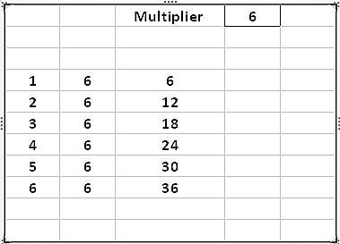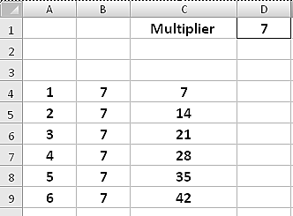
Fig 4.13 Mutiplication Table
Exercise 4.2 Finding compound interest

Let Principle P= 10000, R= 5% and interest is compounded anually. Using a single formula we can compute compound interest for any number of years. In the figure below, what should be formula to be written in cells B4 and C4 that when pulled down give the required result. See Figure 4.14

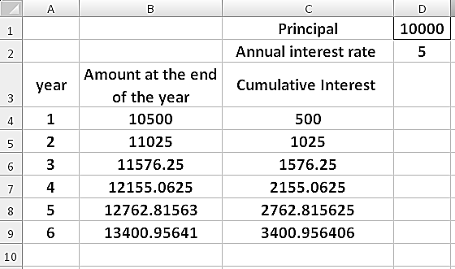

Fig 4.14 Computing Compound interest

Exercise 4.3 Finding compound interest

Finding compound interest with different number of compounding per year. In the figure below, what should be formula to be written in cells B5 and C5 that when pulled down give the required result. See Figure 4.15

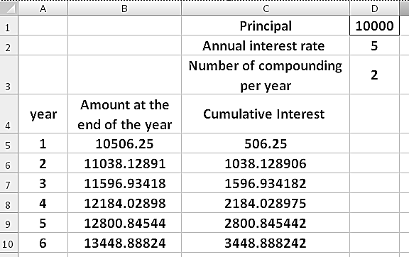

Fig 4.15 Computing Compound interest with more than one compounting per year

Exercise 4.4 Limiting value of amount number of compounding is made infinite

If you go on increase the number of compounding , do you think you can earn larger and larger amount of money as interest. Experiment with P=1, R=100 and number of years =1. Find the amount and interest earned in one year for Number of compounding =1, 10,100 and 1000 . You will notice that the amount at the end of one year convrges towards 2.716.
This is a very important number designated as “e” in mathematics. See Figure 4.16

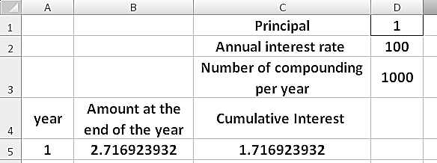
Fig 4.16 Limiting value of amount number of compounding is made infinite

4.2 Summary
Mastery of the use of relative, absolute and semi-absolute addressing schemes are essential for effective use of spreadsheets. It reduces the job of writing formulas in every cell for some of the repetitive tasks. .
4.3 Problems (use Excel to solve following problem by explicit computation)
- Compute sin(x)/x for x in radians ranging from 1 to 0.01 in steps of 0.01 . Find to which value it is approaching
- Compute (1+(1/n) )^{n} for n starting from 1 to 1000 in steps of 10. . Find to which value it is approaching
- Find 100th Fibonacci number . Firse few Fibonacci numbers are 1,1,2,3,5… . It follows a recurrence relation F_{n} = F_{n-1} + F_{n-2} starting with F₁ = 1 and F₂=1
- In Hanoi tower problem, if number of discs n = 10 , howmany steps are required to transfer all discs. . It follows a recurrence rekation F_{n} = 2F_{n-1} + 1 starting with F₁ = 1
- Generate first 5 terms in the series 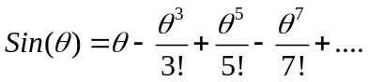 for 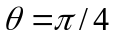 and sum with sign to get approximate value of 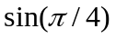
- Evaluate the function 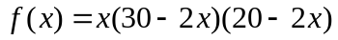 for x ranging from 0 to 10 in steps of 0.5 . Find out for what value of x the function become maximum.
- Find out howmany years are required for a sum of Rs 1000 to double if the interest rate is 10% and interest is compounded twice in a year.
4. 4 References for further reading
[1] Nitin Mehta, Excel For Engineering and Scientific Computing, http://www.engineers-excel.com/
[2] Gerard Verschuuren, Excel for Scientists and Engineers, Holy Marco publishers, 2005
[3] David M Bourg, Excel Scientific and Engineering Cookbook, An Aresenal of Data Analysis Techniques, O'Reilly Media, 2006
[4] Robert De Levie Advanced Excel for Scientific Data Analysis, Oxford University Press, 2008
[5] S. C. Bloch Excel for Engineers and Scientists, Second Edition, Wiley 2003
4.5 Websites for Excel Tutorials
[1] www.mrexcel.com/
[2] http://www.officetutorials.com/
[3] http://www.exceltip.com/
[4] www.engineers-excel.com/

